Test Report Template

Name | yamil rojas parra | Date | 29/06/2022
Project/Task | /Proyecto/3a_psp1

Test Name/# | Test 1
Test Objective | - Calculate plan added and modified size given an estimated proxy size of x_{k} = 386.
Test Description | - Calculate the regression parameters and correlation coefficients between estimated proxy size and actual added and modified size in Table
Test Conditions | 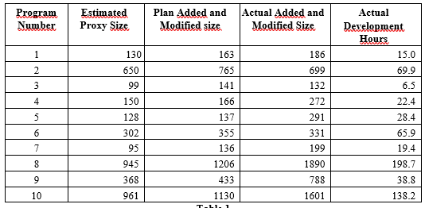
Expected Results | 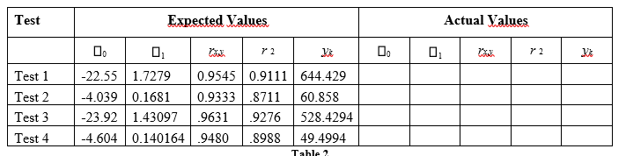
Actual Results | SumX = 3828.0  SumY = 6389.0  SumXX = 2540284.0  SumXY = 4303108.0  SumYY = 7604693.0  AvgX = 382.8  AvgY = 638.9  B1 = 1.727932426206986  B0 = -22.552532752034267  Rxy = 0.9544965741046826  YK = 644.4293837638623  R = 0.9110637099775758

Test Name/# | Test 2
Test Objective | - Calculate time estimate given an estimated proxy size of x_{k} = 386.
Test Description | - : Calculate the regression parameters and correlation coefficients between estimated proxy size and actual development time in Table 1.
Test Conditions
Expected Results
Actual Results | SumX = 3828.0  SumY = 603.2  SumXX = 2540284.0  SumXY = 411628.6  SumYY = 71267.12  AvgX = 382.8  AvgY = 60.32000000000001  B1 = 0.16812664988162895  B0 = -4.038881574687551  Rxy = 0.9333068981405511  YK = 60.858005279621224  R = 0.871061766116737

Test Name/# | Test 3
Test Objective | . Calculate plan added and modified size given an estimated proxy size of x_{k} = 386.
Test Description | - Calculate the regression parameters and correlation coefficients between plan added and modified size and actual added and modified size in Table 1
Test Conditions
Expected Results
Actual Results | SumX = 4632.0  SumY = 6389.0  SumXX = 3741346.0  SumXY = 5242927.0  SumYY = 7604693.0  AvgX = 463.2  AvgY = 638.9  B1 = 1.430966943551199  B0 = -23.92388825291539  Rxy = 0.9631140931490527  YK = 528.4293519578474  R = 0.9275887564223222
Test Name/# | Test 4
Test Objective | Calculate time estimate given an estimated proxy size of x_{k} = 386.
Test Description | - : Calculate the regression parameters and correlation coefficients between plan added and modified size and actual development time in Table  1.
Test Conditions
Expected Results
Actual Results | SumX = 4632.0  SumY = 603.2  SumXX = 3741346.0  SumXY = 503075.7  SumYY = 71267.12  AvgX = 463.2  AvgY = 60.32000000000001  B1 = 0.14016352638883628  B0 = -4.6037454233089505  Rxy = 0.9480329874300507  YK = 49.49937576278185  R = 0.8987665452555467

